# ­­CHAPTER FOUR

## IMPLEMENTATION AND TESTING/RESULTS AND DISCUSSION

### 4.1 Implementation

The implementation of the Student Disciplinary Committee (SDC) Application contains several key aspects, including the design of screens for the mobile application, incorporation and usage of open source tools available, source control and tracking of modifications via the GitHub cloud based software.

#### 4.1.1 Design

The design of the mobile app screens was a critical aspect of the SDC Application development. The structure of the SDC Application mobile app screens was well developed. This work was designed using Figma, a collaboration tool that lets the creation of clickable interfaces for managing SDC cases to be easily developed. The concept followed the Taguchi concept of lay-out, emphasizing on the usability aspects, leading to the creation of easily transposable lay-out. They were created to provide an environment in which users can create new cases, include offenders to these cases, define case types, view cases and using various forms and descriptions give an understanding of what a case is. The below are some of the screenshots.

**Figure 7**

*Logo design*



Note: The app logo that is shown when the app initially starts up

**Figure 8**

*Splash screen and the login screen design*

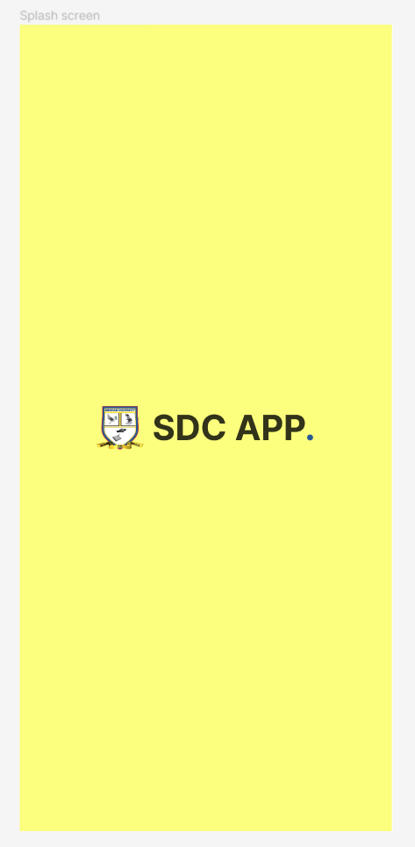

Note: The figma design of the mobile applications splash screen

**Figure 9**

*The home screen design and a particular case screen design*

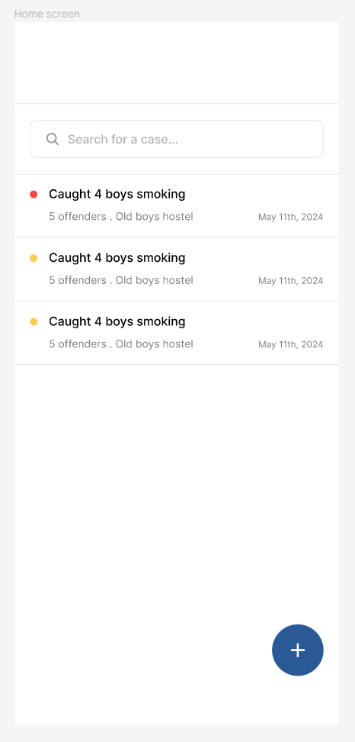 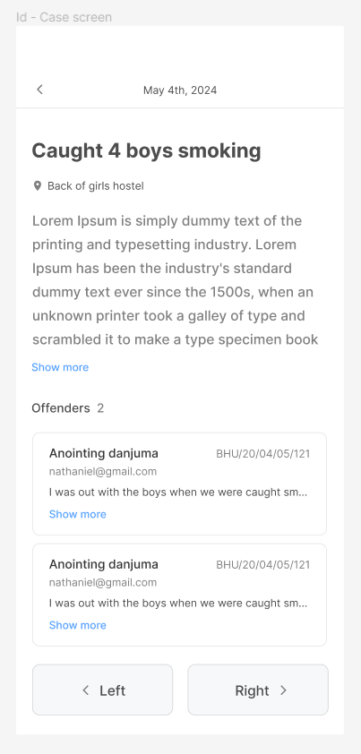

Note: The above are figma designs showing the home screen where all the application screens are displayed and an individual case screen that displays more information on a case

**Figure 10**

*The case form design and an offenders modal design*

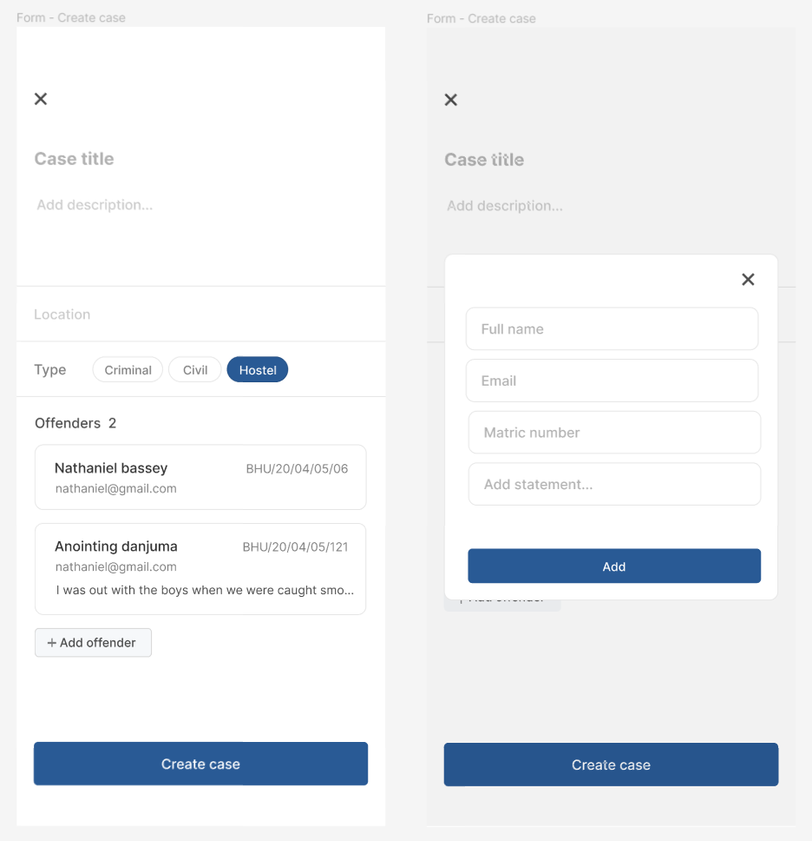

Note: The above are figma designs showing a form that allows for the creation of cases and also the adding of offenders during the process

#### 4.1.2 Tools

Several open-source tools were instrumental in building the SDC Application:

**DrizzleORM:** Used for managing the application's database queries, providing a simple, lightweight and efficient way to handle interactions. And it is also type safe, which makes it that much indispensable.

**TursoDB:** Employed as a serverless SQLite for production, offering a lightweight and scalable database solution.

**Zustand & React Query:** Used for managing the application's state and handling data fetching, providing a robust and efficient way to manage data (Very important).

**React Native & Expo SDK 51.0:** Utilized for building the mobile app, allowing for the development of cross-platform applications with a single codebase.

**Bun, Next API Routes & Hono:** These tools were used to build and run the backend code on the edge using the vercel platform, enabling faster performance and improved user experience.

**Figure 11**

*The backend deployed on vercel*

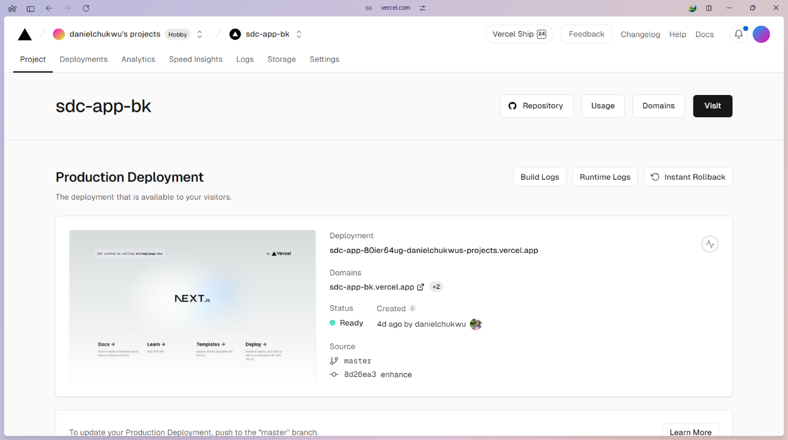

Note: The deployed backend of the mobile application on the vercel platform

#### 4.1.3 GitHub Repository Codebase Screenshots

The backend and frontend codebases for the SDC Application were hosted in separate GitHub repositories. The backend repository contains the server-side code, including API endpoints and database interactions, while the frontend repository contains the code for the mobile app interface.

**Figure 12**

*The mobile interface github repository*

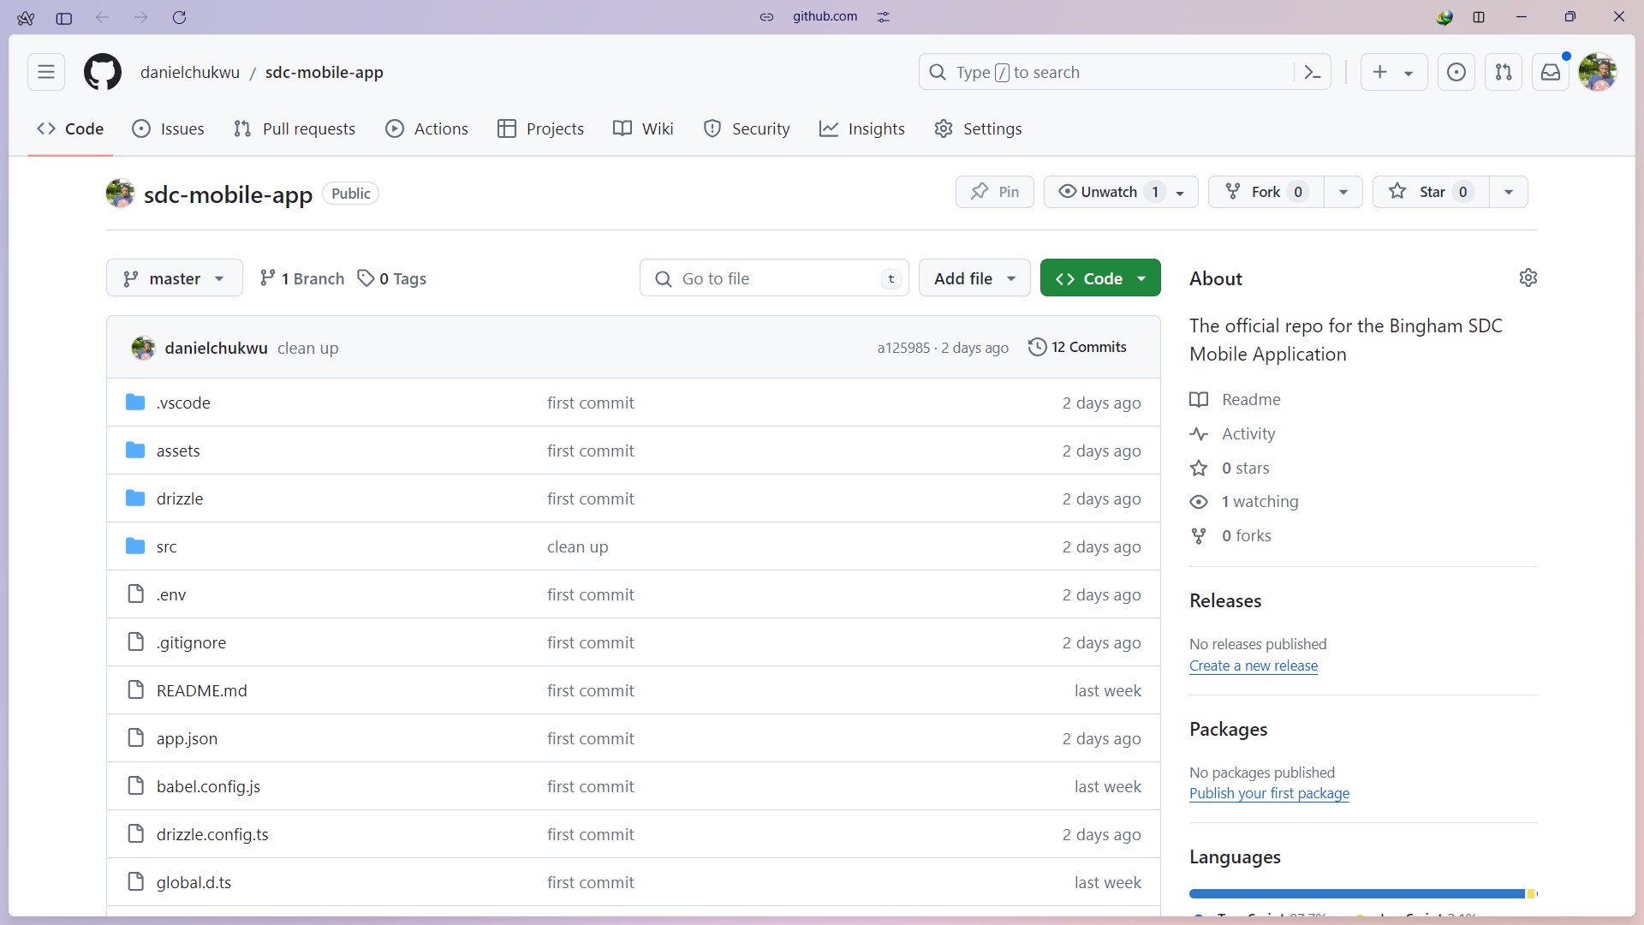

Note: The code repository for the mobile apps source code

**Figure 13**

*The backend github repository*

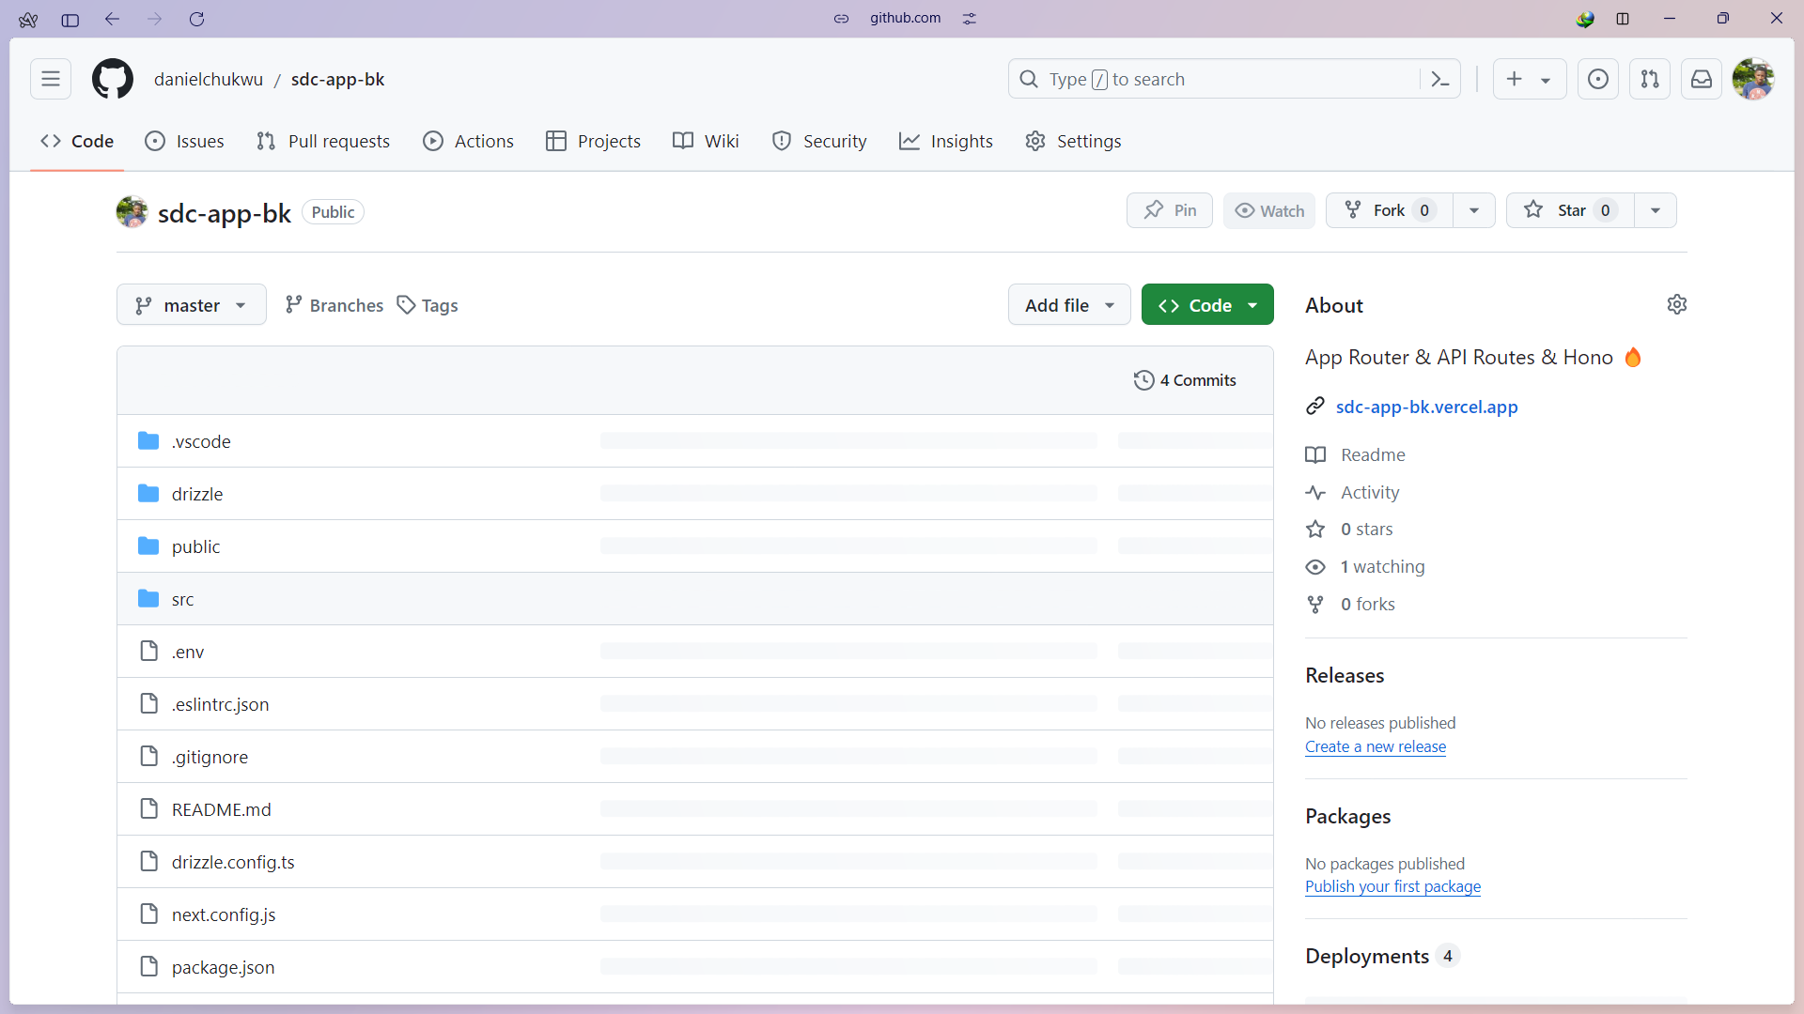

Note: The code repository for the backend of the application

#### 4.1.4 Database Implementation

The database used for the Student disciplinary committee application (SDC) is SQLite production ready turso database, which provides an SQLite for Production service, it is also a serverless solution that offers scalability and reliability for data storage. Turso SQLite for Production provides a CLI tool that enables developers to develop locally and easily switch to the hosted database in production.

**Figure 14**

*SDC application turso database*

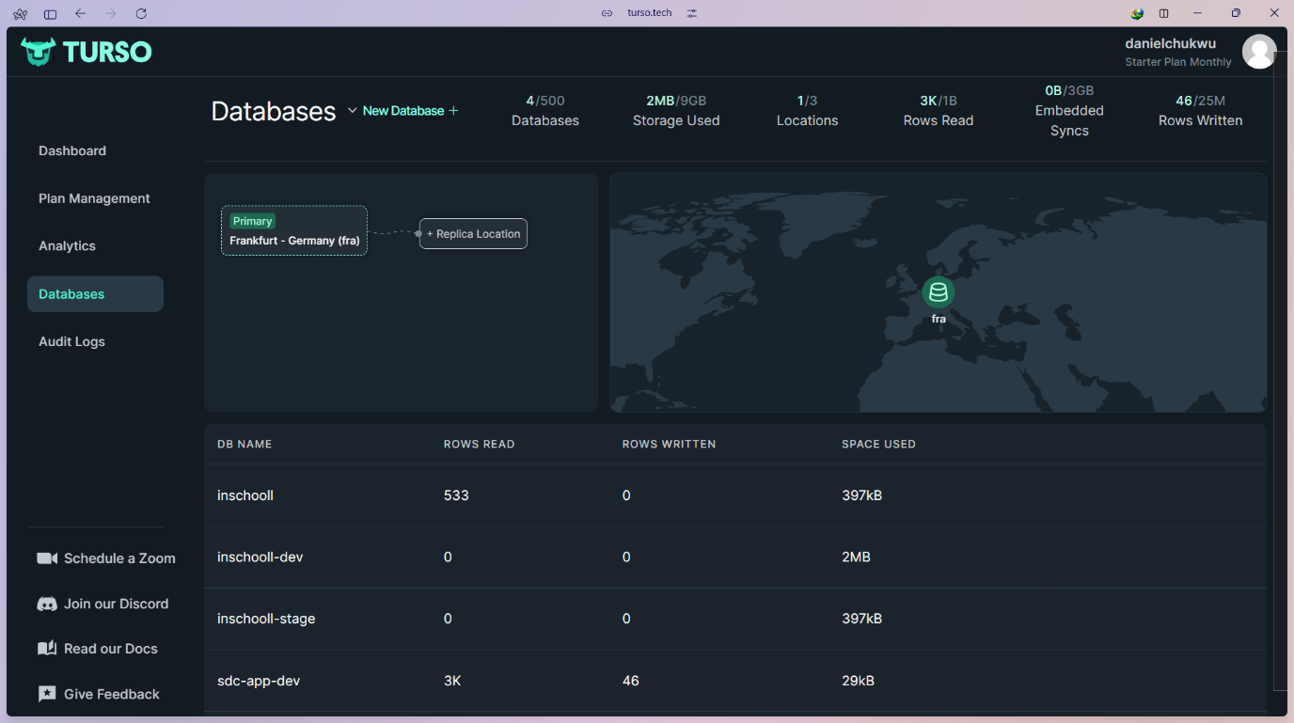

Note: The dashboard of the database service providers used for building this application

**Figure 15**

*Raw SQL JOIN query*

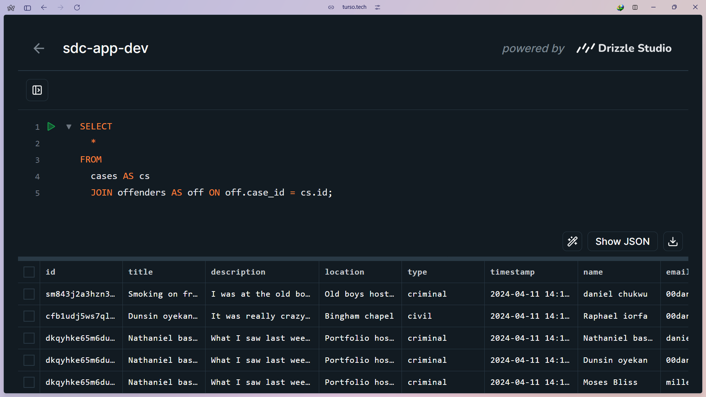

Note: A simple JOIN SQL query that returns records with cases and offenders of those cases

**Figure 16**

*Offenders’ database table*

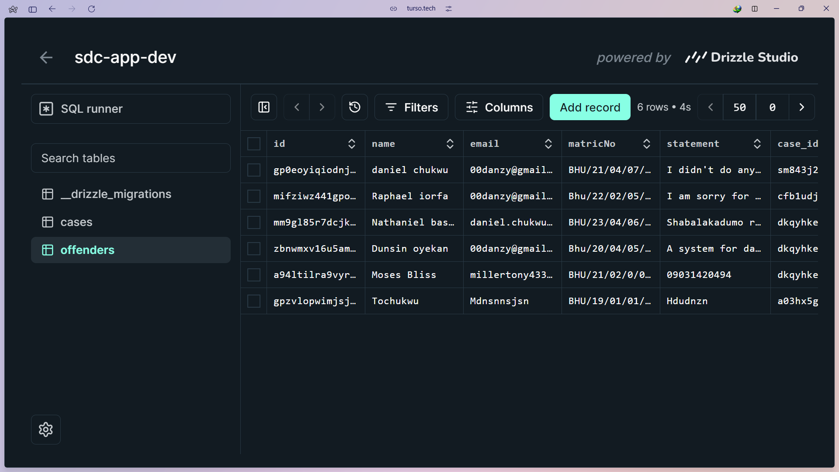

Note: Offenders database table records, displayed using the drizzle studio GUI

#### 4.1.5 Final product

The below figures show the result of the development process so far.

**Figure 17**

*Mobile app splash screen*

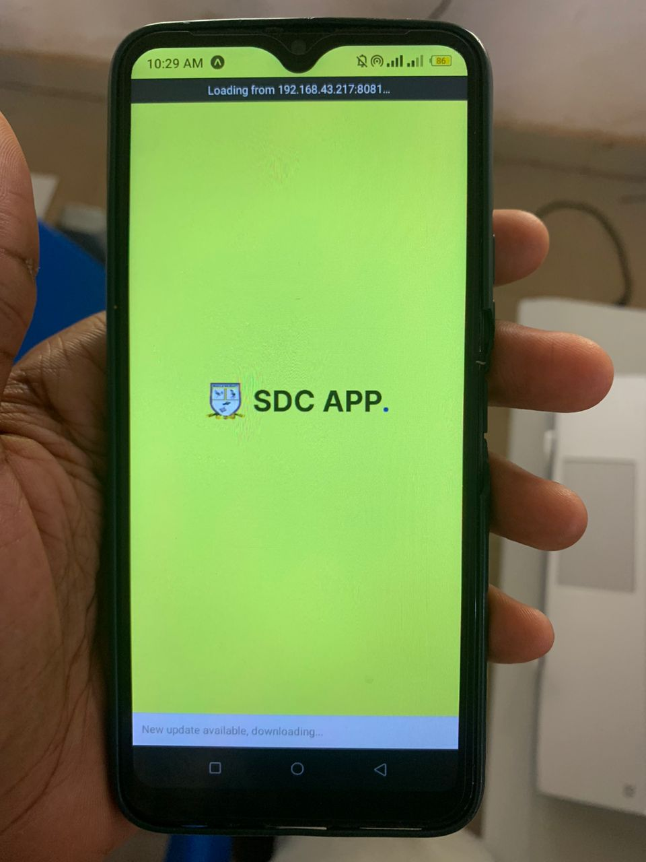

Note: This is the splash screen, it is the first screen that is shown when the mobile application is opened

**Figure 18**

*List of cases screen and a particular case screen*

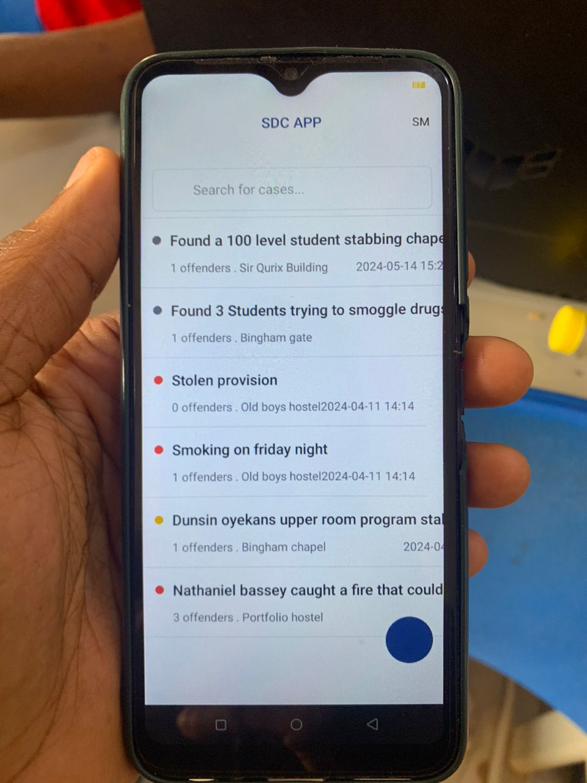 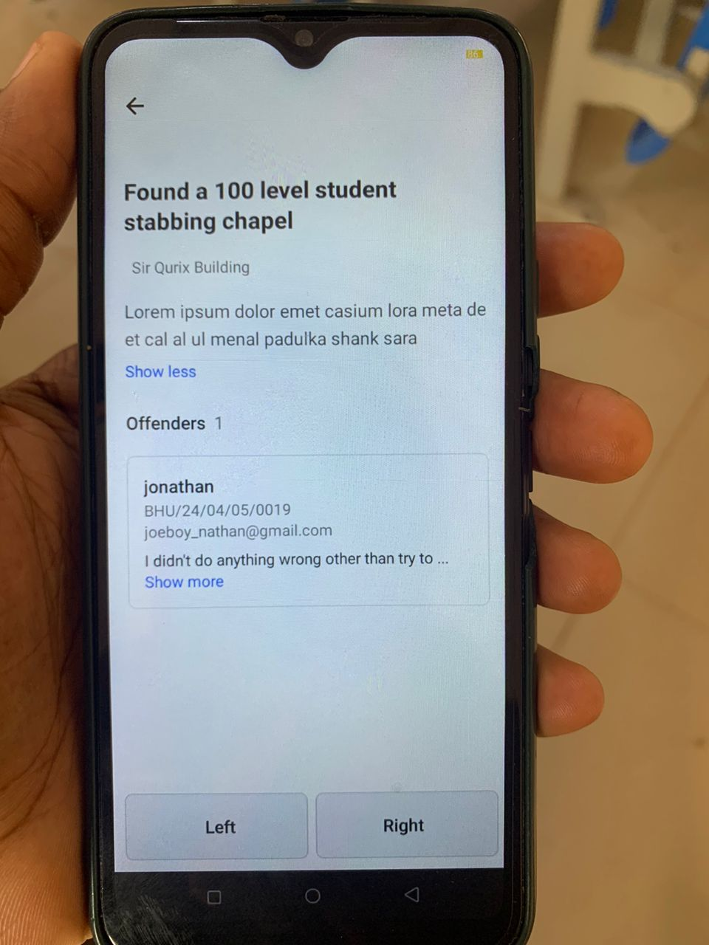

Note: The above shows the home screen which holds a list of already created cases and a dynamic screen that displays more information on a particular case

**Figure 19**

*Case creation screen and an offenders form dialog/modal*

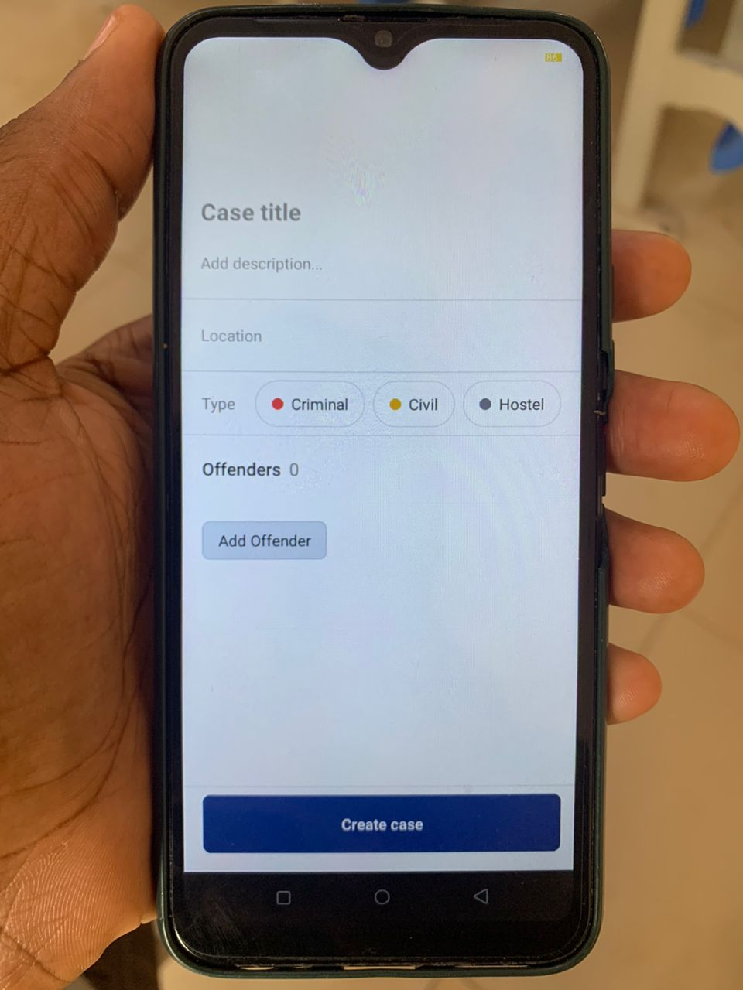 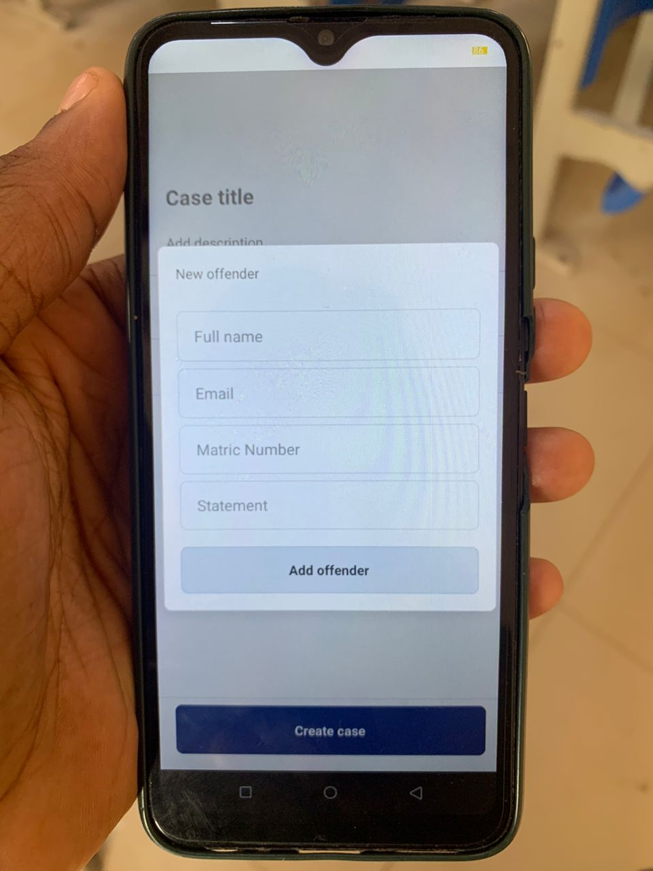

Note: The above screens enable new cases to be created and added to the pool of existing cases

### 4.2 Testing

The testing of the SDC Application was carried out using the following libraries:

1. **jest:** Jest is an amazing, robust, industry-standard JavaScript Testing Framework used by some of the biggest tech companies in the world. It works with projects using: Babel, TypeScript, Node, React, and more. Hence making it a no brainer for the development of the SDC Application.
2. **react-test-renderer:** This package provides an experimental React renderer that can be used to render React components into pure JavaScript objects, without depending on the DOM or a native mobile environment in our case. Which is extremely important.

By using Jest and react-test-renderer, the testing process for the SDC Application is streamlined, making it possible to write more comprehensive tests for the app's components and functionalities.

#### 4.2.1 Unit Testing

Jest and react-test-renderer libraries were used to unit test all the application components and utility functions. The screenshots below show some of these tests.

**Figure 20**

*Test files*

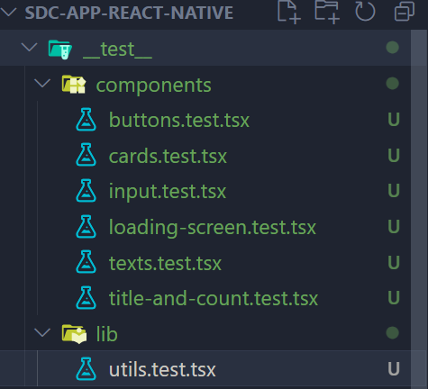

Note: The above are the test files that exist in the codebase of this project

**Figure 21**

*Unit test code for a card component*

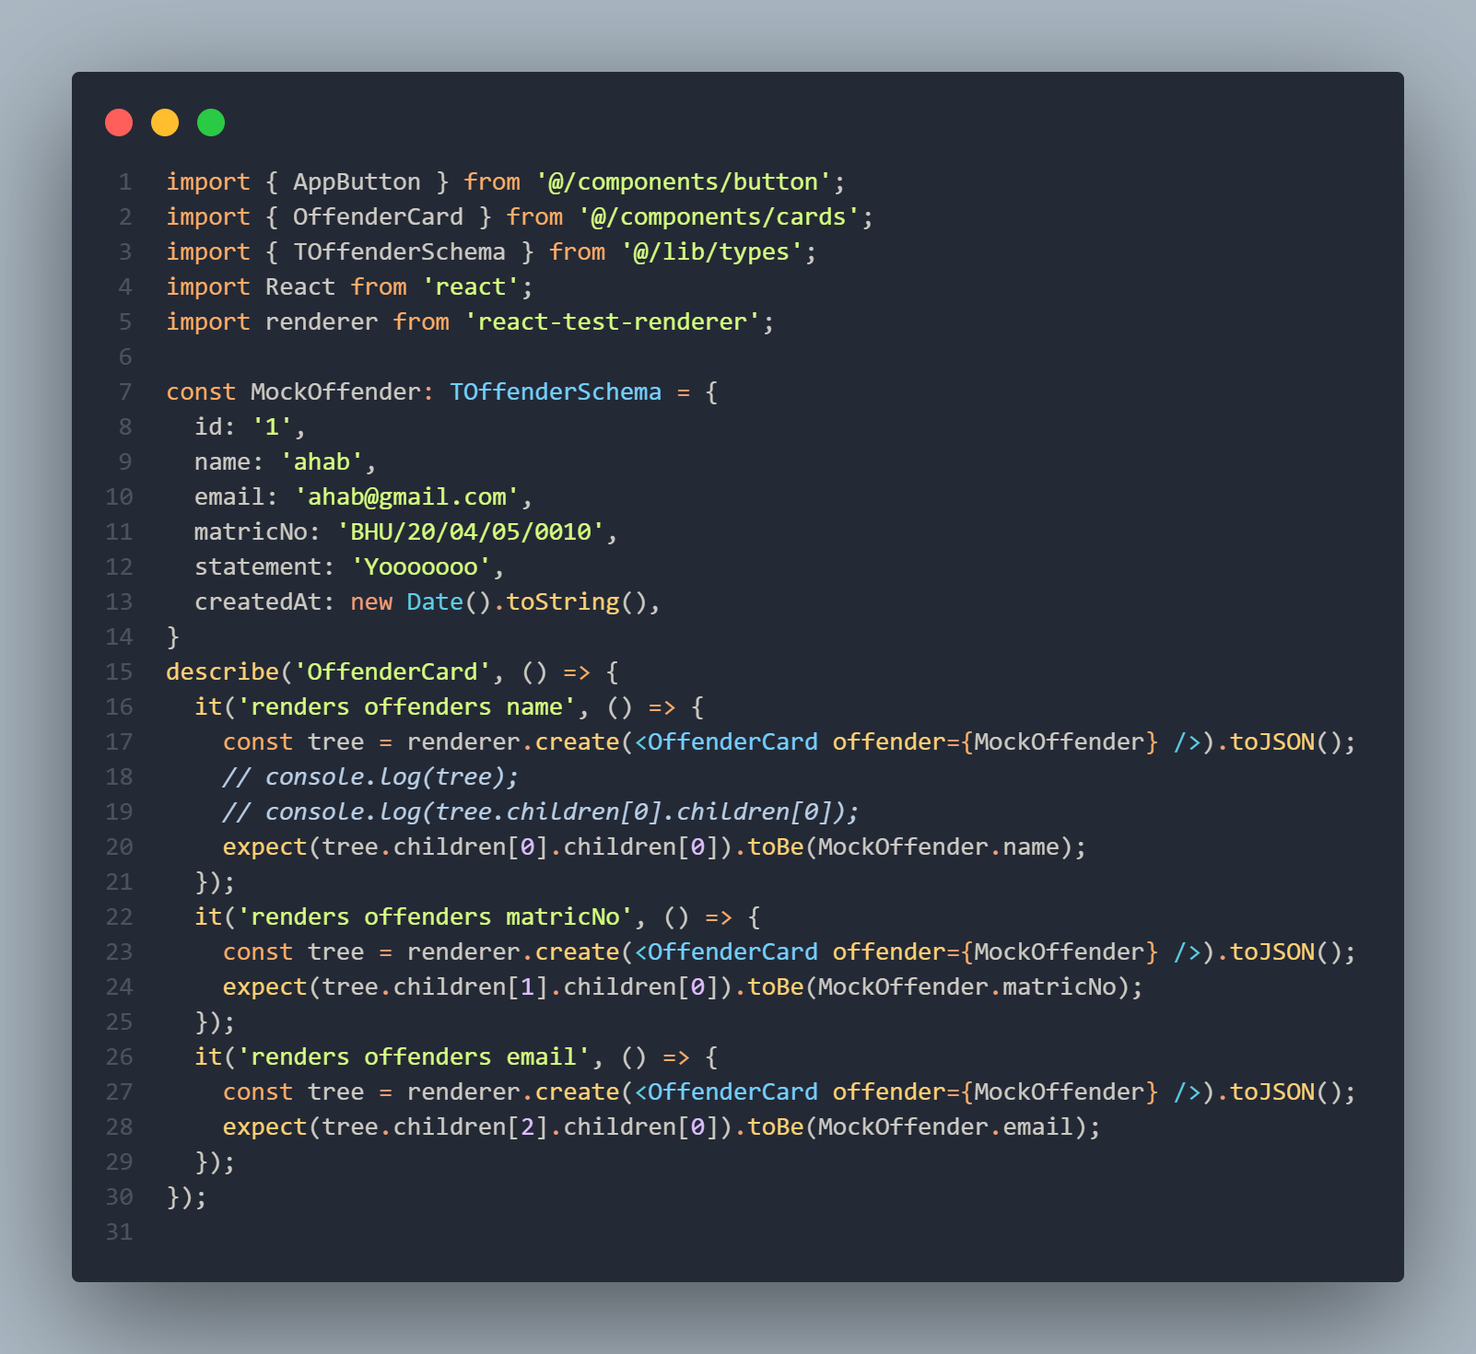

Note: This is a code snippet showing the test code for a particular unit of the application, precisely the OffenderCard component.

**Figure 22**

*Executed test results*

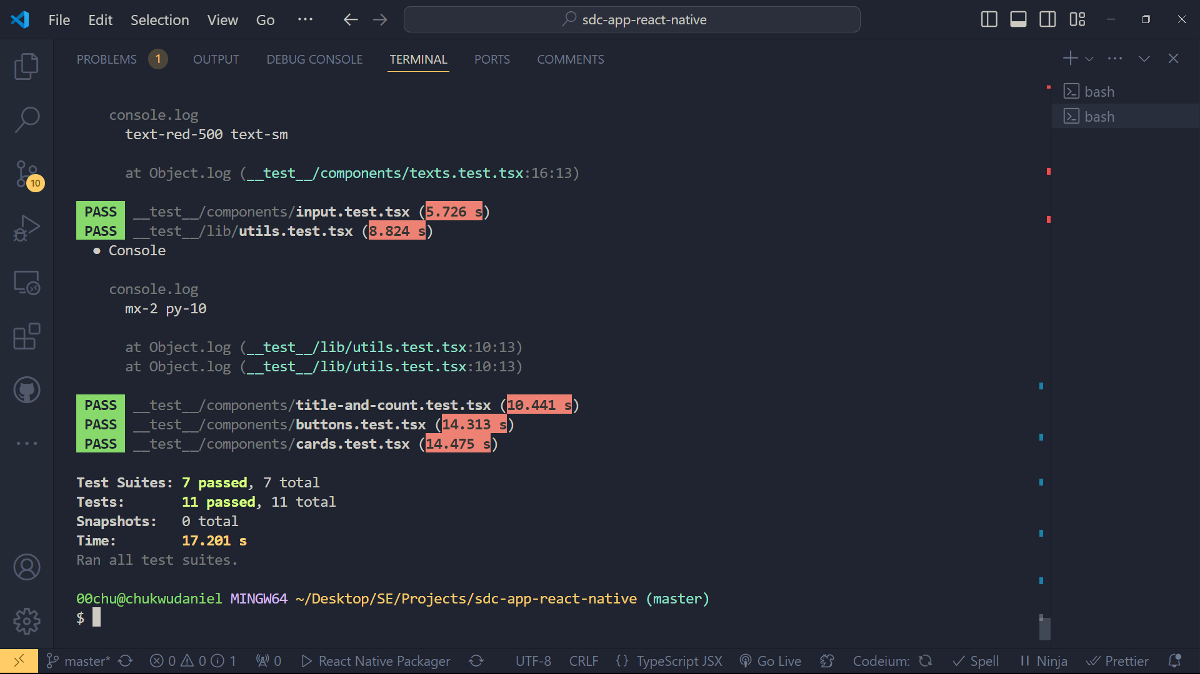

Note: This are the test results that are gotten when the test suites in the codebase are executed

# CHAPTER FIVE

## SUMMARY, CONCLUSION AND RECOMMENDATION

### 5.1 Summary

The intended goal of this project was to design a mobile application to address the need for a Student Disciplinary Committee Application (SDC) to enhance the process of handling disciplinary cases among universities. A set of key recommendations was collected with these general ideas about design and features of the application as a result of a qualitative research that included a quantitative part, which included interviews with the users, case studies, observations. Agile was used as the project development methodology given that it is highly flexible and requires constant engagement with the stakeholders.

#### 5.1.1 Major Findings:

**i. Design and Development:**

The mobile app screens were developed to give friendly user interface to interact when handling cases of discipline. It interesting to note that the project utilized different types of open-source tools among them being DrizzleORM, TursoDB, React Query, React Native, and Expo SDK 51. 0, Bun, Next API Routes, and Hono are all examples of the diverse applications of API routes. To keep the codebase of the backend and the frontend organized, the two codes were hosted on different GitHub repository.

**ii. Database Implementation:**

TursoDB (an SQLite for production database) was employed as the database solution for the application, as it comes with a ton of helpful, out-of-the-box features that aid developers in building apps faster and paying much more attention to the development of the product rather than the managing of a physical server and having to handle all the bottlenecks that come with going down that part.

**iii. Testing:**

Jest and react-test-renderer were adopted to guarantee the application’s reliability and its ability to run through diverse tests. These tools enabled the comprehensive testing of individual elements(units) and the whole platform of the Web Application to be implemented on mobile devices without involving the DOM or the native environments for the mobile devises.

**iv. Challenges Encountered:**

Interoperability was one issue using multiple tools needed a lot of coordination and compatibility tested needed to be conducted. One of the major technical issues that remained a concern for the company was implementing adequate data security and making sure that system could be easily scaled. It was very challenging to get a broad range of user feedback into one paper, so it was important to carefully plan and execute the process.

### 5.2 Conclusion

From the SDC Application project, it is now obvious that technology plays a crucial role in the efficiency of disciplinary cases management in schools. The modern tools in software development and the efficient methodologies employed paved way for building a sound and very friendly application. First, the research methodology conducted during the project was effective in all aspects of it by identifying the key requirements and possible issues in planning, designing, development, implementation, and evaluating the project of a social media platform for promoting education among the youth. These studies point to the conclusion that the extension of disciplinary procedures through digital channels makes them more open and understandable, improves communication between participants, and simplifies the work of both administrators and students.

### 5.3 Recommendation

Based on the findings of the study, the following recommendations are proposed:

**Wider Implementation:** Universities should consider adopting similar digital solutions to streamline their disciplinary processes. The SDC Application can serve as a model for other institutions seeking to enhance their case management systems.

**Continuous Improvement:** The application should be updated from time to time where possible taking into consideration the feedback from the users and the new features they may require in the course of their activity. Also, some updates and maintenance should be constantly done regularly so that it can remain effective and secure.

**Training and Support:** All users, including the SDC members should undergo comprehensive programs of training in the use of the application. The users will require help to get the best out of the application through technical support being provided at later intervals.

**Further Research:** Further study should examine the organizational culture and students’ behavior changes over a long time in institutions where such digital disciplinary systems have been implemented. Furthermore, there are other options to improve the model, including additional functional opportunities like the utilization of artificial intelligence in analytics and report generation automation.

**REFERENCES**

Blandford, S. (1998). Discipline in schools. Google Books. https://books.google.com.ng/books?hl=en&lr=&id=13oaXCiHbqAC&oi=fnd&pg=PT10&dq=discipline+in+schools&ots=8As7gpBeVD&sig=7DsMbOiKdVSHXb2KOiqoyHJfYpg&redir_esc=y

Mao, J., Vredenburg, K., Smith, P. W., & Carey, T. (2005). The state of user-centered design practice. Communications of the ACM, 48(3), 105–109. https://doi.org/10.1145/1047671.1047677

Hung, L. D. (2023). Web development with T3 stack. Theseus. https://www.theseus.fi/handle/10024/802481

Esfahani, H. C., & Yu, E. (2010). A repository of agile method fragments. In Springer eBooks (pp. 163–174). https://doi.org/10.1007/978-3-642-14347-2_15

Villarreal, D. L. (2021, March 8). Students constitutional rights and the university disciplinary committee. HeinOnline. https://heinonline.org/HOL/LandingPage?handle=hein.journals/ncclj3&div=9&id=&page=

Karlesky, J. J., & Stephenson, D. G. (1971). Student disciplinary proceedings: Some preliminary questions. The Journal of Higher Education, 42(8), 648–656. https://doi.org/10.1080/00221546.1971.11774894

Reddick, S. R. (2020). Due process rights in student disciplinary matters. HeinOnline. https://heinonline.org/HOL/LandingPage?handle=hein.journals/jcolunly14&div=17&id=&page=

J. Crim. L. & Penal Stud. (2019). The authority of disciplinary committee for students to oblige third parties to a specific behavior. HeinOnline. https://heinonline.org/HOL/LandingPage?handle=hein.journals/jlocllwap23&div=34&id=&page=

Notar, C. (2009, September 1). Disciplinary action committee (DAC). | Education | EBSCOhost. EBSCOhost. https://openurl.ebsco.com/EPDB%3Agcd%3A10%3A1154874/detailv2?sid=ebsco%3Aplink%3Ascholar&id=ebsco%3Agcd%3A44016929&crl=c

Pedley, J. (2007). The development of a student contract and improvement in student disciplinary procedures at Massey University. HeinOnline. https://heinonline.org/HOL/LandingPage?handle=hein.journals/anzled12&div=8&id=&page=

Heyman, I. M. (2022). Some thoughts on university disciplinary proceedings. HeinOnline. https://heinonline.org/HOL/LandingPage?handle=hein.journals/calr54&div=13&id=&page=

Picozzi, J. M. (2020). University disciplinary process: What's fair, what's due, and what you don't get. HeinOnline. https://heinonline.org/HOL/LandingPage?handle=hein.journals/ylr96&div=87&id=&page=

Bayrami, M. (2020, April 21). A comparison of personality characteristics and coping strategies in students with record in disciplinary committee of university and normal students. Tabriz University Journal. https://psychologyj.tabrizu.ac.ir/article_4213.html?lang=en

Ige, S. (2016). Factors influencing disciplinary committee effectiveness: The case of public secondary schools in Ondo State, Nigeria. DigitalCommons@Fayetteville State University. https://digitalcommons.uncfsu.edu/jri/vol4/iss3/3/

Aloka, P. J. O., & Bojuwoye, O. (2023). Gender differences in decisions on student disciplinary behaviours by disciplinary panels of selected Kenyan secondary schools. https://journals.co.za/doi/abs/10.10520/EJC136364

Stoner II, E. N., & Martineau, B. J. (2019). Disciplinary and academic decisions pertaining to students in higher education. HeinOnline. https://heinonline.org/HOL/LandingPage?handle=hein.journals/jcolunly27&div=20&id=&page=

Papadakis, M. A., Hodgson, C. S., Teherani, A., & Kohatsu, N. D. (2004). Unprofessional behavior in medical school is associated with subsequent disciplinary action by a state medical board. Journal of Medical Regulation, 90(1), 16–23. https://doi.org/10.30770/2572-1852-90.1.16

Wilson, J. M. (1996). Processes for resolving student disciplinary matters. New Directions for Student Services, 1996(73), 35–52. https://doi.org/10.1002/ss.37119967305

Walton, T. K. (2019). Protecting student privacy: Reporting campus crimes as an alternative to disclosing student disciplinary records. HeinOnline. https://heinonline.org/HOL/LandingPage?handle=hein.journals/indana77&div=10&id=&page=

Daud, N. M., & Mohamed, I. S. (2009). Evaluating technology resistance and technology satisfaction on students’ performance. Mendeley, 26(4), 298–312. https://doi.org/10.1108/10650740910984637